Contact
Becky Lyle Pinkard
External Relations Manager
(757) 672-9906
blylepinkard@forkids.org
MEDIA ADVISORY: The Landmark Center Dedication & Community Celebration

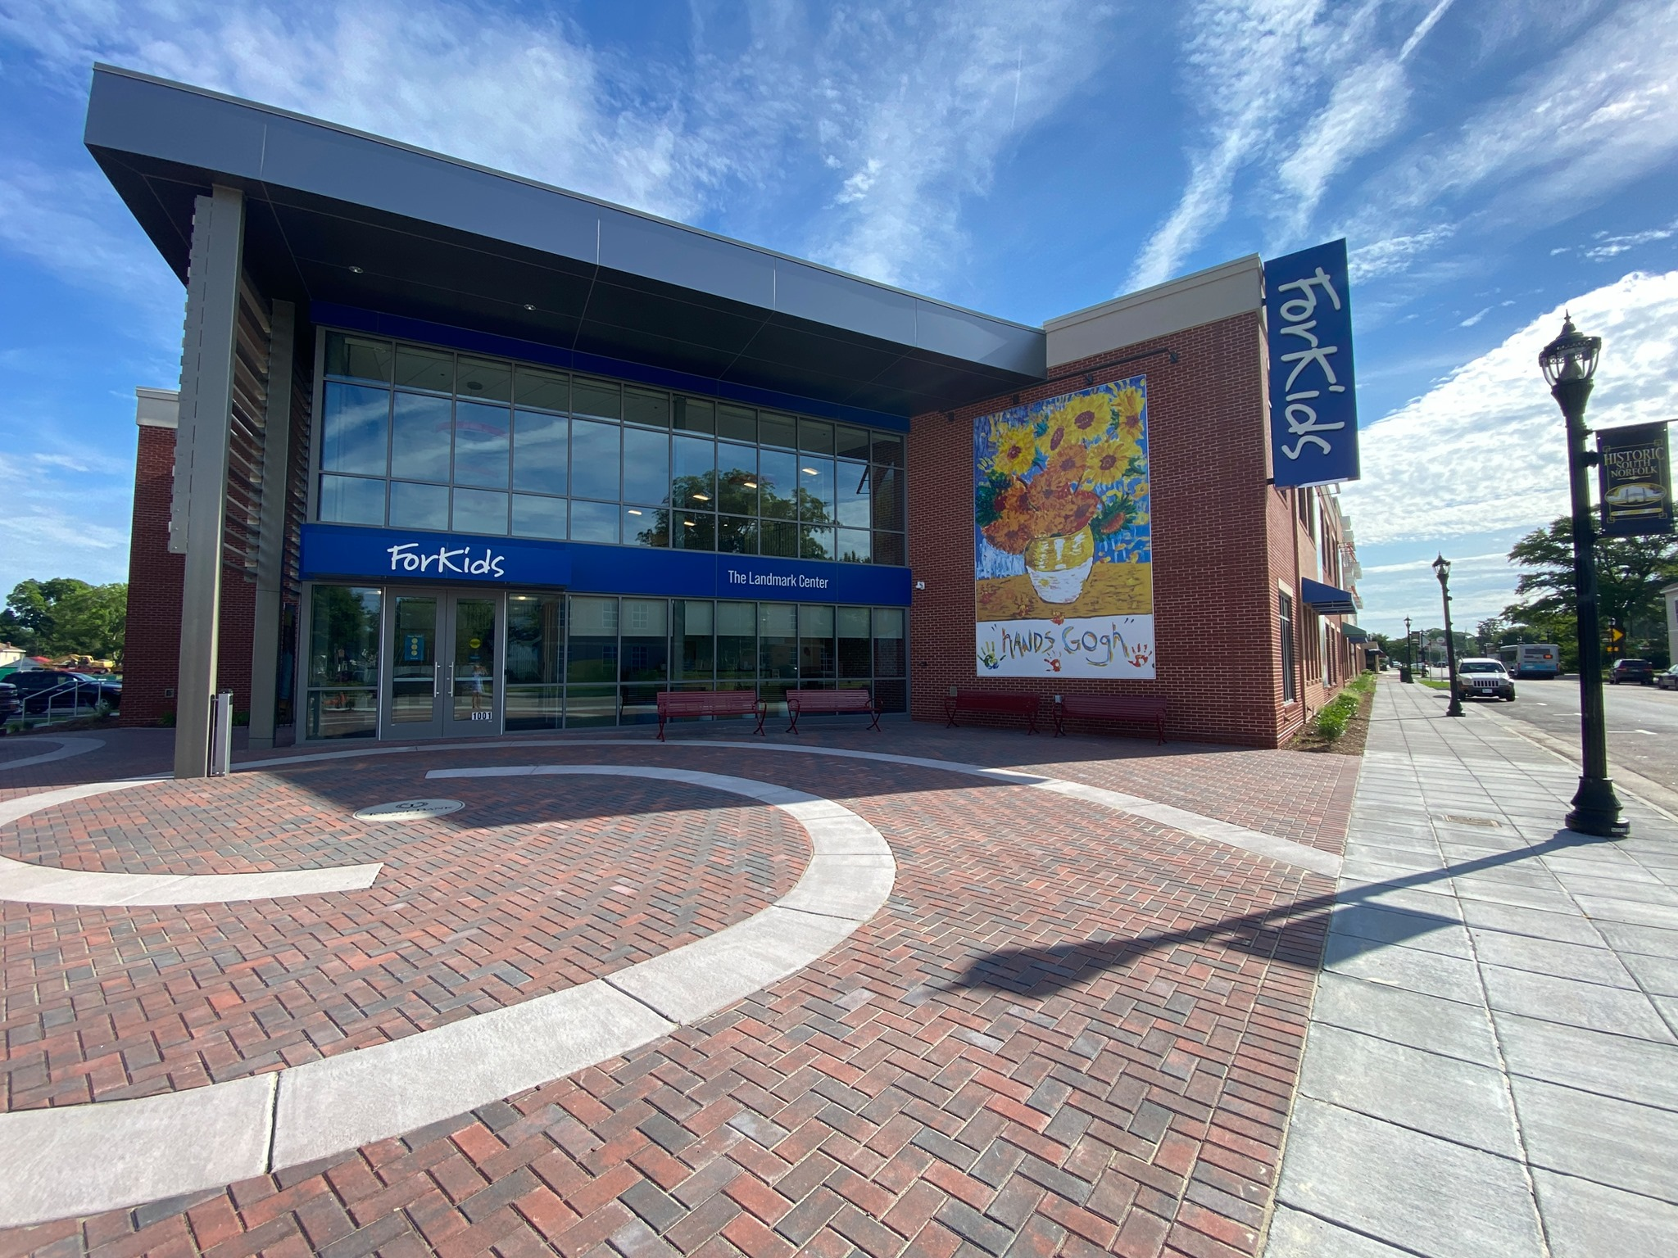
Chesapeake, VA – October 14, 2021 – With bands, confetti bombs, bubble wagons and hundreds of guests, ForKids will celebrate the completion of The Landmark Center and their $25 million Campaign ForKids. The afternoon’s events include ribbon cutting, building tours, food, face painting, street games, and performances by the Oscar Smith High School Strolling Strings and the Virginia Symphony Orchestra.

Why It is Important: A nationally unprecedented project, The Landmark Center incorporates a research center, afterschool "Learning Hub," urban orchard, 24-seat call center, commercial teaching kitchen, and a family shelter. With 252 works of art by ForKids children and almost 1,000 plants, the 64,000 s.f. complex is designed to reduce traumatic stress and provide a joyful, creative environment for families and staff. The project was embraced by the historic community of South Norfolk as a catalyst for redevelopment. Over 110 ForKids employees work in the new facility.

The Landmark Center project is part of the $25 million The Campaign ForKids, which also funded The Birdsong Center, a regional services center in Suffolk, dedicated in November of 2018. Over 305 private donors as well as the cities of Chesapeake, Suffolk, Norfolk, Portsmouth, and Virginia Beach supported the Campaign. The Landmark Foundation provided the lead gift of $5 million.
Brief remarks will be made by Frank Batten, Jr., Honorary Campaign; Co-Chair; Marie Finch, Campaign Chair; Mayor Rick West, City of Chesapeake; and Thaler McCormick, ForKids CEO.

Media Availability
ForKids is inviting members of the media to attend the Dedication & Celebration event

WHEN: Sunday, October 17, 2021, 12:30-3:30pm; ribbon-cutting ceremony from 1:15-1:45pm
WHERE: 1001 Poindexter Street, Chesapeake, VA 23324
Event speakers will be available for interviews. If interested, please call Becky Lyle Pinkard at (757) 672-9906. Photos and video footage will be made available after the event.

About The Landmark Center:
ForKids Corporate and Service Headquarters - 60,000 sq.ft. (plus 4,000 sq.ft. roof garden) building, The Landmark Center will connect more than 85,000 individuals across 14 cities and counties in Southeastern Virginia annually to services. The Center is home to Sokol Place, a 135-bed family shelter; the Batten Learning Hub, a 5-classroom learning center with the capacity to tutor 120 children nightly; the 24-seat Housing Crisis Hotline serving 14 cities and counties across Southeastern Virginia, responding to over 60,000 calls annually; and the new McCormick Research & Advocacy Center, providing data and analytics to inform public policy and service innovations.

###
About ForKids
ForKids, inc. is a non-profit agency founded 33 years ago with a mission to break the cycle of homelessness and poverty for families and children. The ForKids Housing Crisis Hotline is the central point of contact for all persons experiencing a housing crisis throughout Southeastern Virginia. On any given day, ForKids in-depth programs assist approximately 290 families including 870 children; our critical services now touch the lives of over 70,000 individuals each year. Services include counseling, tutoring, field trips, summer camps, classes in life skills, parenting, budgeting, GED tutoring, job coaching and case management. For more information, please visit www.forkids.org or call (757) 622-6400.

